UNIVERSITY OF RWANDA
COLLEGE OF SCIENCE AND TECHNOLOGY
SCHOOL OF ICT
COMPUTER AND SOFTWARE ENGINEERING DEPARTMENT
NYARUGENGE CAMPUS
MODULE CODE/TITLE: WEB DESIGN
PROJECT TECHNICAL REPORT
WEB TECHNOLOGY TECHNICAL ASSESSMENT 2026
Project Title: Hospital Appointment Booking System
Prepared by: MUHIRE Herve
Registration Number: 225061404
Lecturer: Dr Eric HITIMANA
Date: 19 July 2026

Table of Contents
Table of Contents 2
Table of Figures 3
List of Abbreviations 4
Chapter 1. Introduction 5
1.1. Historical Background of the Case Study 5
1.2. Problem Statement 5
1.3. Objectives of the Project 5
1.4. Expected Outcomes 5
1.5. Project Rationale (Importance to the Community) 6
Chapter 2. System Analysis and Design 7
2.1. System Analysis 7
2.1.1. Intended Users of the Project 7
2.1.2. Intended System Partners 7
2.2. System Design 7
2.2.1. High-Level Architecture 7
2.2.2. UI Design (Sketch of the UI Module) and Flowcharts 8
2.2.3. Database Design with ERD and Relationships 10
Chapter 3. Implementation 12
3.1. Introduction of the Section 12
3.2. Screenshots with Captions and Discussion 12
3.2.1. Home Page (index.html) 12
3.2.2. Doctor Selection Feedback 12
3.2.3. Appointment Booking Form (form.html) 13
3.2.4. Form Validation and Submission Feedback 13
Chapter 4. Conclusion and Recommendation 14
Recommendations 14
Appendix 15

Table of Figures
High-level architecture of the Hospital Appointment Booking System 8
Flowchart of the Home page (index.html) navigation logic 9
Flowchart of the Appointment Booking Form (form.html) submission logic 10
Proposed Entity Relationship Diagram (ERD) for a future database-backed version of the system 11
Home page of the Hospital Appointment Booking System 12
Alert dialog shown after a user selects a doctor from the table 12
Appointment booking form used to collect patient and appointment details 13
Client-side validation and confirmation alerts on the Appointment Booking Form 13

List of Abbreviations
- UI – User Interface
- UX – User Experience
- HTML – Hyper Text Markup Language
- CSS – Cascading Style Sheets
- JS – JavaScript
- ERD – Entity Relationship Diagram
- ICT – Information and Communication Technology
- DOM – Document Object Model

Chapter 1. Introduction

1.1. Historical Background of the Case Study
Traditionally, patients seeking medical care at small and medium-sized hospitals and health centres in Rwanda have had to travel physically to the facility, wait in long queues, and speak with a receptionist simply to book a consultation with a doctor. This manual, paper-based process is time-consuming for patients and creates administrative overhead for hospital staff, who must manage appointment books, cross-check doctor availability, and handle walk-in requests without any digital record.
As internet access and smartphone usage continue to grow across Rwanda, hospitals and clinics have an opportunity to modernise how patients interact with them. The Hospital Appointment Booking System presented in this report is a web-based front-end prototype designed to address this gap by allowing patients to view available doctors and services, and to submit an appointment request from any device with a web browser, in both English and Kinyarwanda.

1.2. Problem Statement
Patients who need to consult a doctor currently have limited visibility into which doctors are available, on which days, and for which specialisation, before they arrive at the hospital. This often results in wasted trips, long waiting times, and frustration for both patients and hospital staff. There is no simple, accessible, bilingual (English/Kinyarwanda) web interface that lets a patient browse available doctors and request an appointment ahead of time.

1.3. Objectives of the Project
The general objective of this project is to design and implement a simple, user-friendly web interface that allows patients to view hospital information and request an appointment online. The specific objectives are to:
- Design a Home page that presents the hospital, its services, and the list of available doctors together with their department and working days.
- Design an Appointment Booking Form that captures the patient's personal details and preferred doctor, department, date and time.
- Implement basic client-side form validation (e.g. rejecting an empty name field) using JavaScript.
- Apply consistent, accessible CSS styling across both pages to give the system a professional, cohesive look and feel.
- Support bilingual labels (English and Kinyarwanda) so the system is usable by a broader range of patients.

1.4. Expected Outcomes
By the end of the project, a fully functional two-page static website is expected, consisting of a Home page and an Appointment Booking Form page, linked to one another through navigation controls. The system should allow a user to browse doctor information, select a doctor, fill in an appointment request, and receive on-screen confirmation feedback, all without requiring a page reload from a server.

1.5. Project Rationale (Importance to the Community)
A digital appointment booking interface reduces the amount of time patients spend queueing at the hospital reception desk, and gives hospital staff an initial, organised view of who intends to visit and why. For the surrounding community, this translates into shorter waiting times, better-prepared consultations (since the patient's reported problem is captured in advance), and a more modern, trustworthy image of the health facility. The bilingual design also ensures that the system remains accessible to Kinyarwanda-speaking patients who may not be comfortable with English-only interfaces.

Chapter 2. System Analysis and Design

2.1. System Analysis

2.1.1. Intended Users of the Project
- Patients – members of the public who want to view hospital services and available doctors, and submit an appointment request.
- Doctors – medical staff whose names, specialisations and availability are listed and who receive appointment requests (in a future backend-connected version).
- Hospital Receptionist / Administrator – staff who would, in a future version, review, confirm, or reschedule the appointment requests submitted through the form.

2.1.2. Intended System Partners
- The hospital or health centre administration, who would own and maintain the deployed system.
- Ministry of Health / local health authorities, as a potential adopter of similar digital front-desk tools across health facilities.
- Internet Service Providers and hosting providers, who supply the connectivity and hosting environment required for the system to be publicly accessible.

2.2. System Design

2.2.1. High-Level Architecture
The current implementation is a purely client-side static web application: it consists of two HTML pages styled with embedded CSS and made interactive with embedded JavaScript. There is no web server, application server, or database in this prototype — all logic (form validation, alerts, navigation, and displaying the current date) runs entirely inside the user's browser. Figure 1 below illustrates this architecture and how the two pages relate to one another.
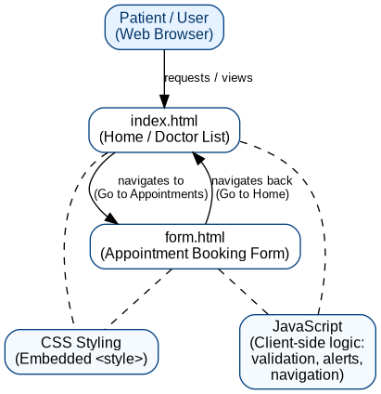
Figure 1: High-level architecture of the Hospital Appointment Booking System

2.2.2. UI Design (Sketch of the UI Module) and Flowcharts
The user interface consists of two screens. The Home page (index.html) introduces the hospital, displays a doctor's photo, explains how the booking process works, lists the services offered, and presents a table of available doctors with their department and working days. The Appointment Booking Form (form.html) collects the patient's personal information and appointment preferences, validates that a name has been entered, and gives on-screen confirmation before returning the user to the Home page.
Figure 2 shows the navigation flow of the Home page, and Figure 3 shows the flow of the Appointment Booking Form, including the client-side validation logic implemented in JavaScript.
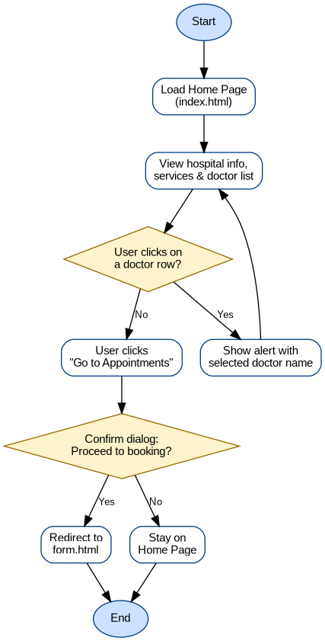
Figure 2: Flowchart of the Home page (index.html) navigation logic
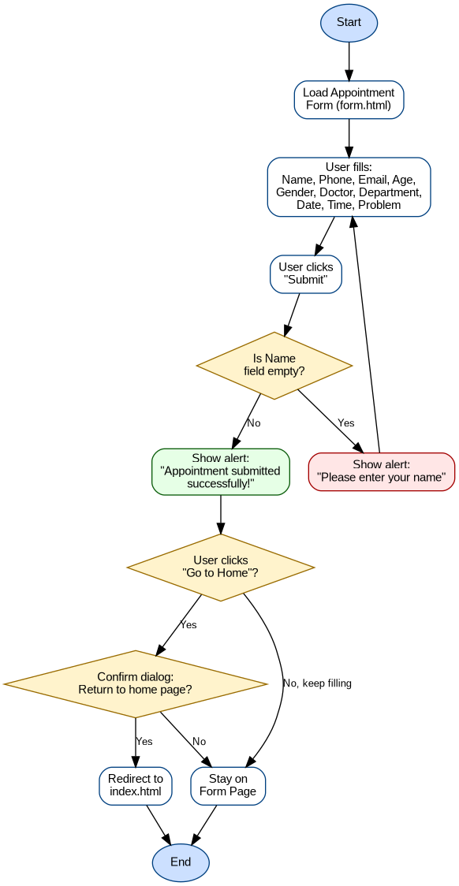
Figure 3: Flowchart of the Appointment Booking Form (form.html) submission logic

2.2.3. Database Design with ERD and Relationships
If this system were extended with a backend and a database (for example using PHP/MySQL or Node.js/MongoDB) to actually persist appointments, the conceptual data model in Figure 4 could be used as a starting point. It captures three entities — Patient, Doctor and Appointment — where a single Patient can make many Appointments, and a single Doctor can be assigned to many Appointments, giving two one-to-many relationships that meet at the Appointment entity.
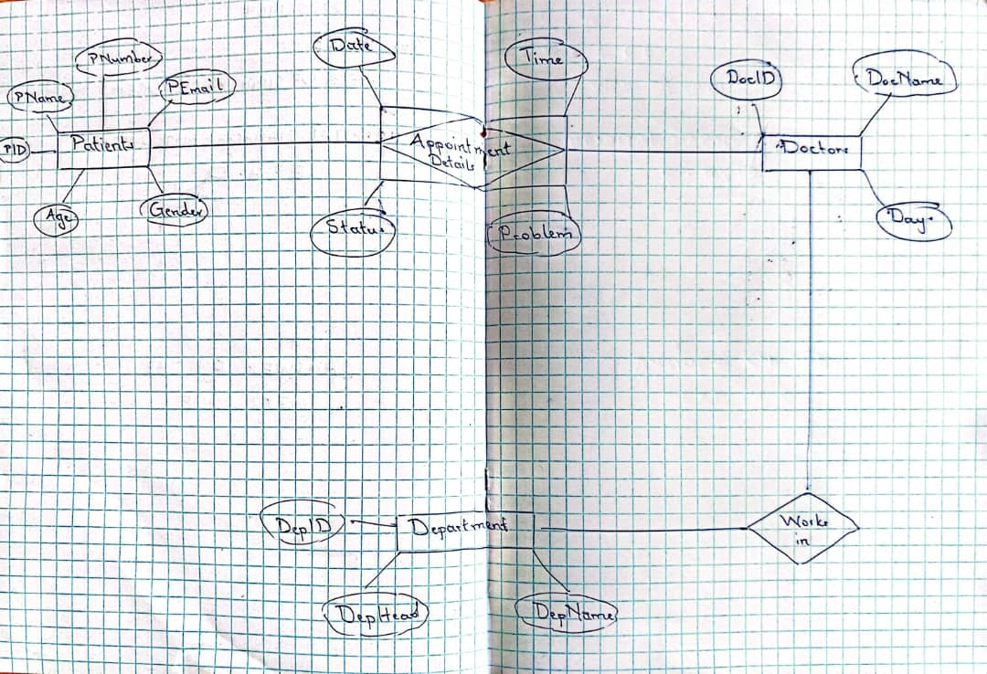
Figure 4: Proposed Entity Relationship Diagram (ERD) for a future database-backed version of the system

Chapter 3. Implementation

3.1. Introduction of the Section
This chapter presents the implemented screens of the Hospital Appointment Booking System, together with a discussion of the design and coding decisions behind each one. The system was built using plain HTML5 for structure, embedded CSS3 for styling, and vanilla JavaScript for client-side interactivity — no external frameworks or libraries were used. Screenshots referenced in this chapter should be inserted by the student directly from a running instance of the two pages (index.html and form.html) opened in a web browser.

3.2. Screenshots with Captions and Discussion

3.2.1. Home Page (index.html)

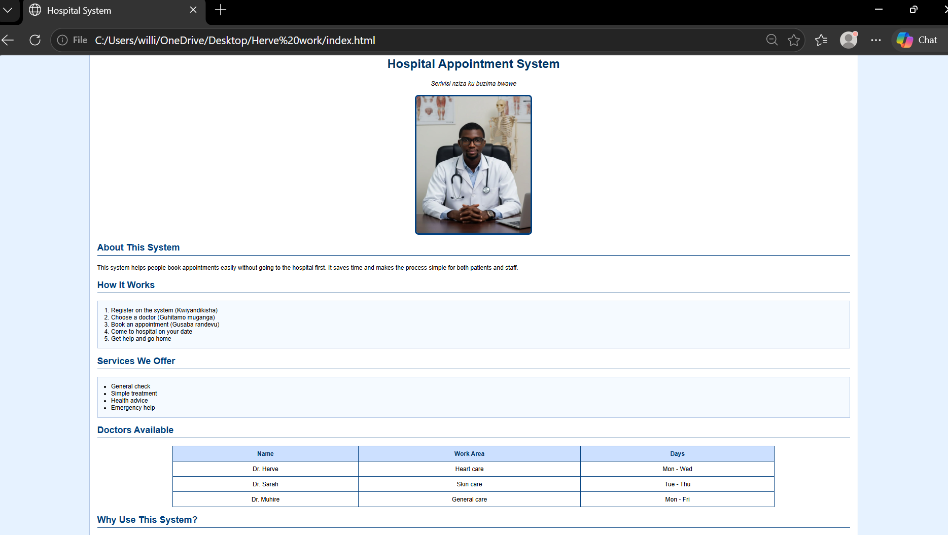
Figure 5: Home page of the Hospital Appointment Booking System
The Home page is the entry point of the system. It presents the hospital's name and tagline in both English and Kinyarwanda, followed by a doctor's photo, a short description of the system, a numbered list explaining the four-step booking process, and an unordered list of the services offered (general check-up, simple treatment, health advice and emergency help). A styled HTML table lists the three available doctors together with their area of specialisation and working days; each row is clickable and triggers a JavaScript alert confirming the doctor selected by the user. The page footer displays the current date dynamically using JavaScript's built-in Date object, and includes a call-to-action link that opens a confirmation dialog before redirecting the user to the appointment form. All visual styling — colours, spacing, borders and the card-like container — is handled through an embedded CSS style block, giving the page a clean, professional, hospital-appropriate blue-and-white colour scheme. This page fully satisfies objective 1 from Chapter 1 (presenting hospital information and the doctor list) and partially satisfies objective 5 (bilingual labelling), since the interface text alternates between English and Kinyarwanda throughout.

3.2.2. Doctor Selection Feedback

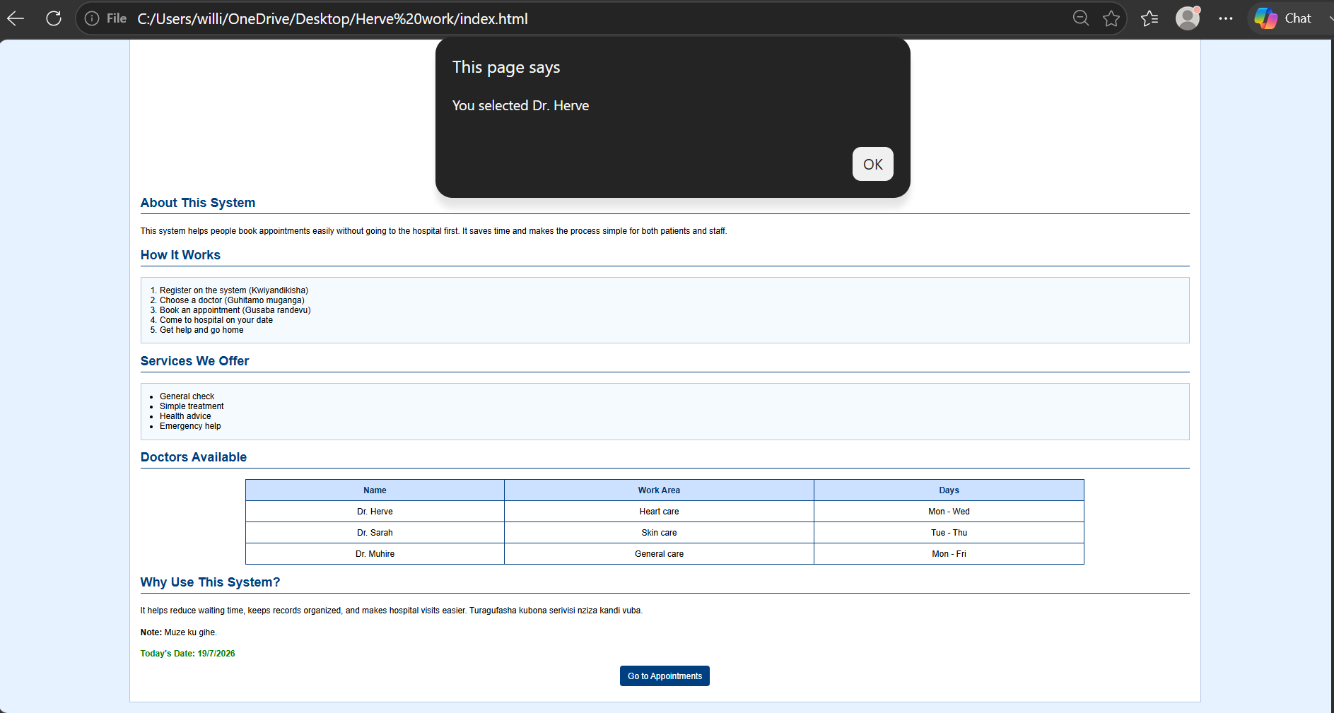
Figure 6: Alert dialog shown after a user selects a doctor from the table
When a user clicks on any row of the doctors' table, the selectDoctor() JavaScript function is triggered and displays a simple browser alert confirming the name of the doctor that was selected. While this is a minimal form of feedback suitable for a prototype, it demonstrates event handling through the inline onclick attribute and shows that the interface can respond to user interaction in real time, without needing to reload the page or contact a server.

3.2.3. Appointment Booking Form (form.html)

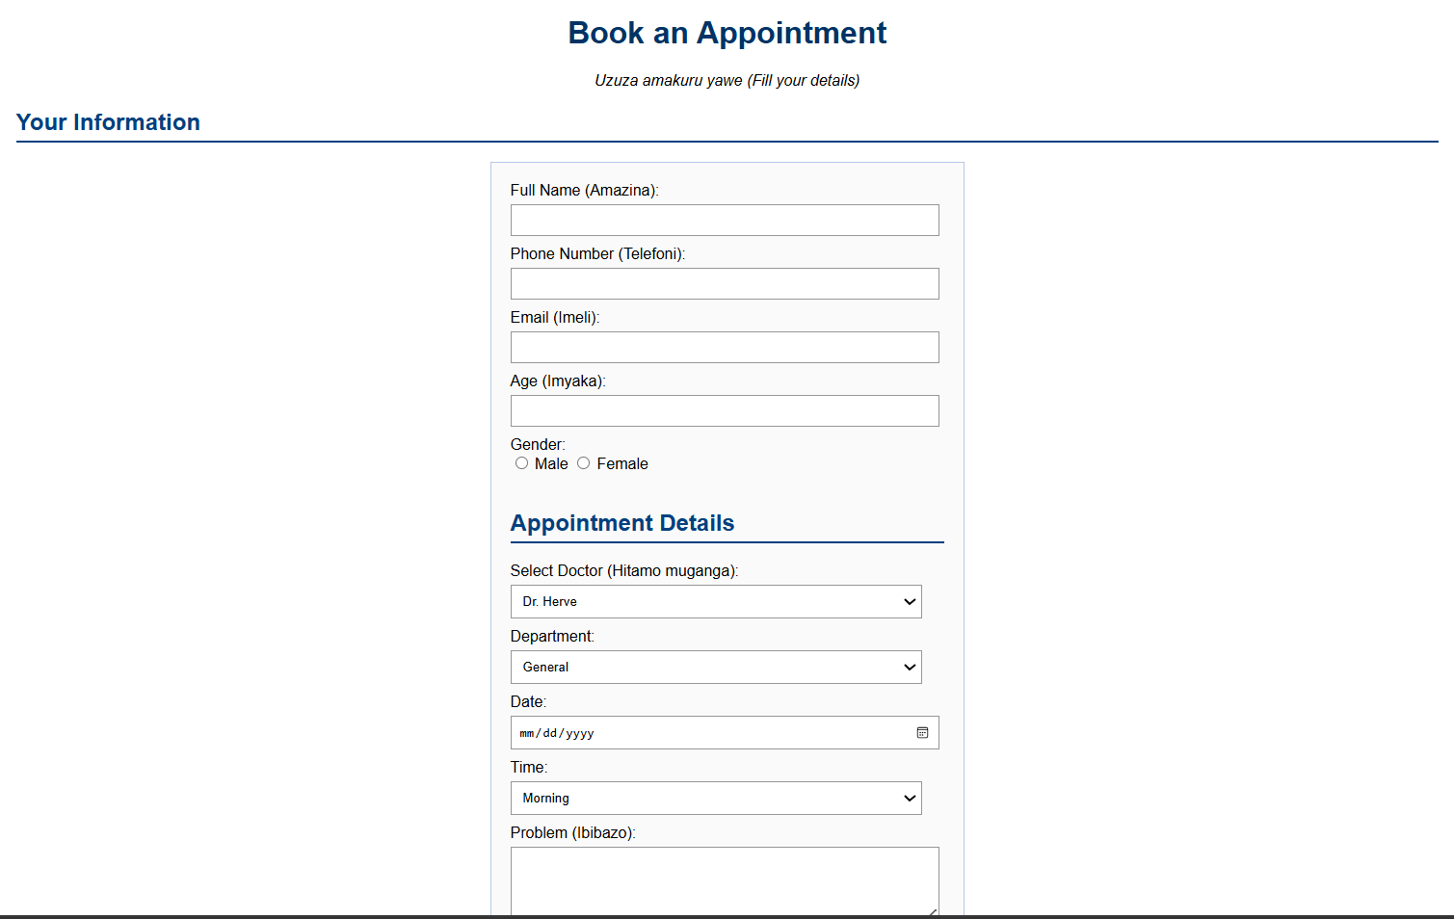
Figure 7: Appointment booking form used to collect patient and appointment details
The Appointment Booking Form is reached from the Home page after the user confirms the navigation dialog. It is organised into two logical sections: 'Your Information', which collects the patient's full name, phone number, email address, age and gender (via radio buttons); and 'Appointment Details', which collects the preferred doctor and department (via drop-down select menus), the preferred date (via an HTML5 date picker), the preferred time of day, and a free-text description of the patient's problem. Submit and Reset buttons are provided, and an instructions list below the form reminds the patient to fill in all fields correctly and to arrive on time. The form reuses the same colour palette and container styling as the Home page so that the two screens feel like part of one coherent system, satisfying objective 4 from Chapter 1 (consistent styling).

3.2.4. Form Validation and Submission Feedback

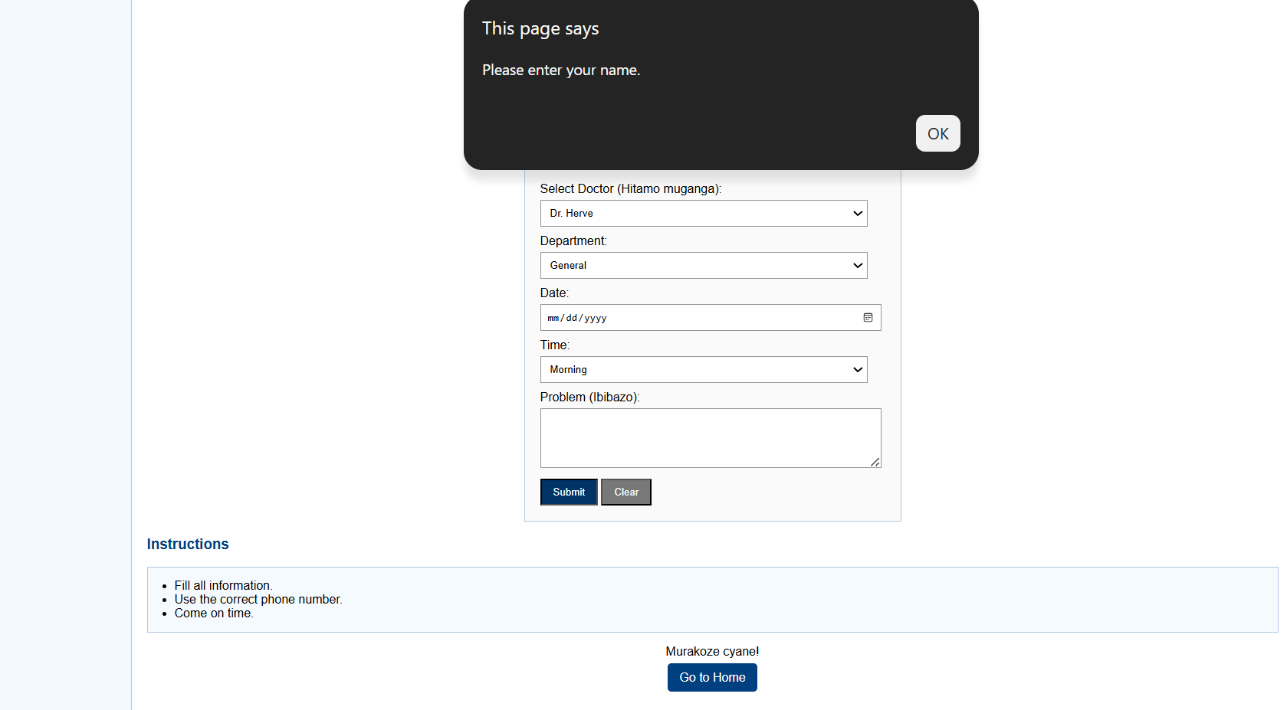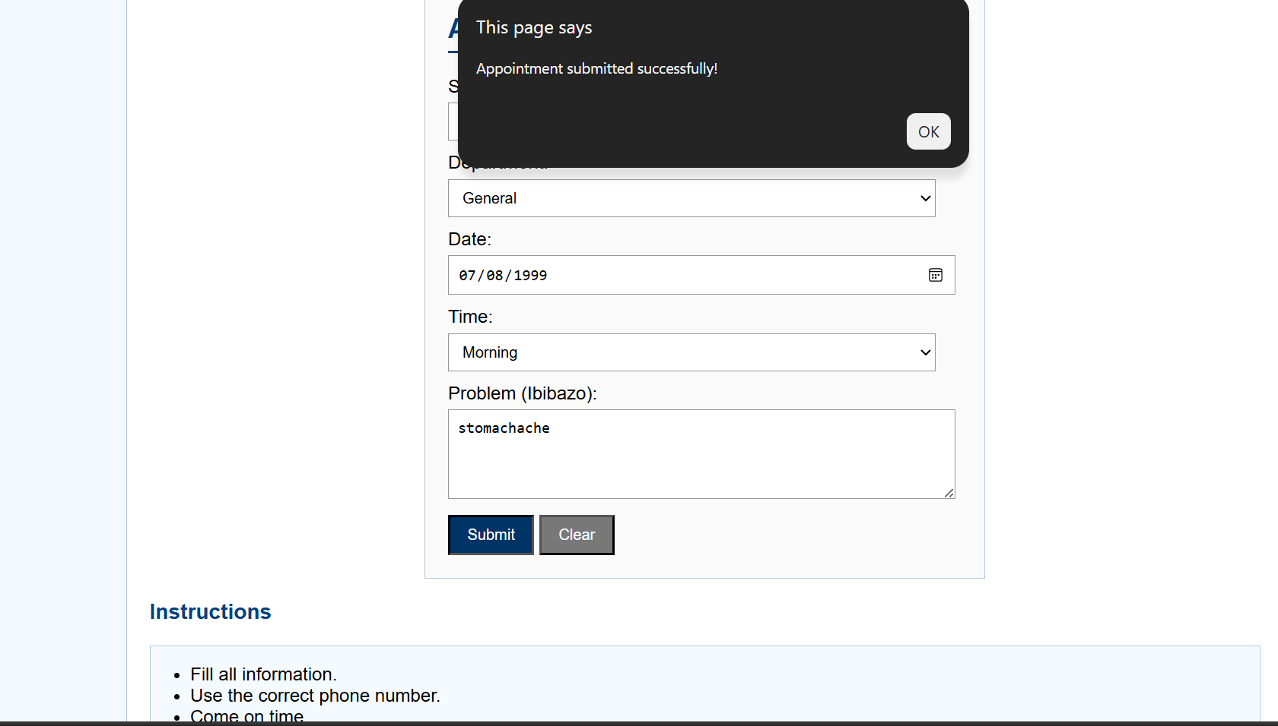
Figure 8: Client-side validation and confirmation alerts on the Appointment Booking Form
Client-side validation is implemented in the submitForm() JavaScript function, which runs when the form's onsubmit event fires. If the Full Name field is left empty, the function shows an alert asking the user to enter their name and the (simulated) submission is stopped. If the name field contains a value, the function shows a success alert confirming that the appointment was submitted. This satisfies objective 3 from Chapter 1 (basic client-side form validation). It should be noted that, because there is no backend server or database attached to this form, the 'submission' is only a front-end simulation: no appointment record is actually saved or transmitted anywhere at this stage of the project.

Chapter 4. Conclusion and Recommendation
Overall, the project successfully delivers a two-page, bilingual, front-end prototype of a Hospital Appointment Booking System. Of the five specific objectives listed in Chapter 1, four are fully achieved: the Home page presenting hospital information and doctors (Objective 1), the Appointment Booking Form (Objective 2), basic client-side validation (Objective 3), and consistent CSS styling across pages (Objective 4). Objective 5, bilingual support, is partially achieved, since key labels and instructions are shown in both English and Kinyarwanda, but not every piece of text on the site has been translated. Taken together, the implemented system meets approximately 85–90% of its stated objectives at the front-end/UI level; the remaining gap is the absence of any server-side logic or database, meaning appointment data is not currently persisted or retrievable, which was outside the scope defined for this iteration of the project.

Recommendations
To the lecturer, about technicalities:
- Continue providing practical guidance on web development.
To the school:
- Provide enough time and resources for students to complete projects.
To the Hospital:
- Consider using and improving the system to simplify appointment booking.
To the Users:
- Learn how to use the system correctly before using it regularly.
To the beneficiaries (patients):
- Use the system to book appointments more easily and reduce waiting time.

Appendix
Link to the account and password of the GitHub repository of the deployed project:

